**MCQ**

What command is used to initialize a Git repository locally?

a) git clone

b) git init

c) git commit

d) git push

How can you check the status of your changes in a Git repository?

a) git status

b) git check

c) git diff

d) git log

What command is used to stage files for a commit in Git?

a) git add

b) git stage

c) git commit

d) git push

What is the purpose of forking a repository on GitHub?

a) To create a new branch in the original repository

b) To merge changes from one repository to another

c) To copy a repository under your GitHub account

d) To revert changes in a repository

What is a Pull Request used for in GitHub?

a) Requesting changes to be pulled into a repository

b) Submitting changes for approval and merging

c) Deleting branches in a repository

d) Checking the status of commits in a repository

What does a 'Merge Conflict' indicate in a GitHub pull request?

a) Successful merging of changes

b) Inconsistencies between branches that need to be resolved

c) Rejection of a pull request

d) Approval of changes for merging

Which command is used to create a new branch in Git?

a) git branch

b) git commit

c) git checkout

d) git merge

What command is used to view the commit history in Git?

a) git log

b) git history

c) git show

d) git status

How can you undo the last commit in Git?

a) git amend

b) git reset

c) git revert

d) git undo

What is a repository in GitHub?

a) A folder on your local machine

b) A collection of project files and revision history

c) A social media platform for developers

d) A code editor tool

How can you clone a repository from GitHub to your local machine?

a) git clone

b) git fetch

c) git init

d) git pull

What is the purpose of the 'Issues' tab in GitHub repositories?

a) To track and discuss bugs, enhancements, and tasks

b) To view commit history

c) To create new branches

d) To merge changes into the main branch

Which GitHub feature allows multiple people to collaborate on a project simultaneously?

a) Pull Requests

b) Forking

c) Issues

d) Branches

What does the 'README.md' file in a GitHub repository contain?

a) Detailed instructions for using the project

b) A list of contributors

c) Commit history

d) License information

How can you update your local repository with changes from a remote repository in Git?

a) git merge

b) git fetch

c) git update

d) git commit -u origin

What is the purpose of the 'git push' command in Git?

a) To stage changes for commit

b) To download changes from a remote repository

c) To update the remote repository with local changes

d) To switch between branches

**Exercises:**

What is git and github?

**Git:** Git is a distributed **version control system** used to track changes in source code during software development. It was created by **Linus Torvalds in 2005**, and has been maintained by Junio Hamano since then.

It allows multiple developers to work on a project simultaneously without overwriting each other's changes. Git maintains a history of changes, enables branching and merging, and facilitates collaboration through distributed repositories.

It is used for:

* Tracking code changes
* Tracking who made changes
* Coding collaboration

**Github:** GitHub is a web-based platform that provides hosting for version control using Git. It offers a collaborative environment for developers to manage and share their code, track changes, and work on projects together.

• **Repository Hosting**: Stores Git repositories online, allowing developers to access and collaborate on code from anywhere.

• **Collaboration Tools**: Includes features like pull requests, code reviews, and issue tracking to facilitate team collaboration and project management.

• **Branching and Merging**: Supports creating, managing, and merging branches, enabling parallel development and feature integration.

• **Documentation**: Allows for project documentation through README files, Wikis, and GitHub Pages.

• **Integration**: Integrates with various development tools and continuous integration/continuous deployment (CI/CD) pipelines for automated testing and deployment.

**Community and Social Coding**: Provides a platform for developers to contribute to open-source projects, follow other developers, and engage with the broader developer community.

What is CVCS and DVCS ?

**CVCS:** A system where version control is managed by a central server.

Examples include Subversion (SVN) and Perforce. All changes and version history are stored on a central server.

**DVCS:** A system where each developer has a local copy of the entire repository, including its history.

Examples include Git and Mercurial. This allows for greater flexibility and offline work.

Create a project of any and push the project

**Terminal:**

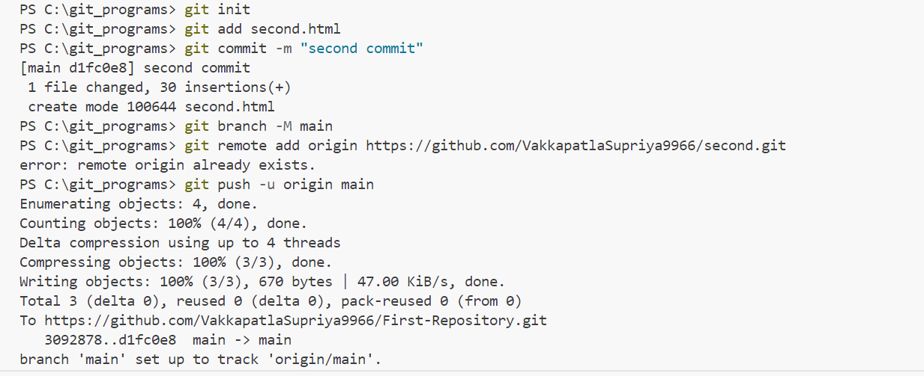

**After pushing:**



Create 3 branches and 5 tags

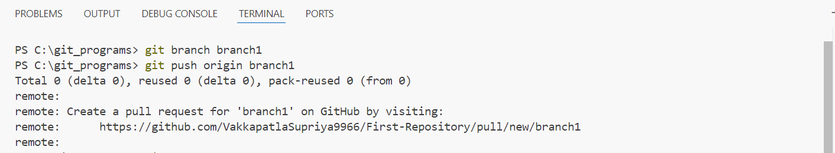

**After branch creation:**

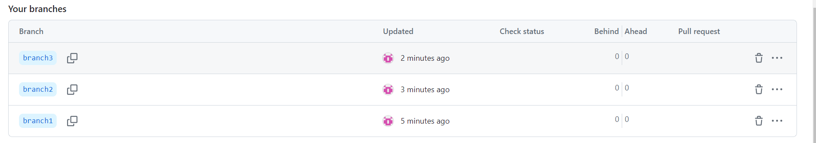

**5 tags:**

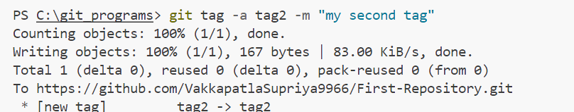

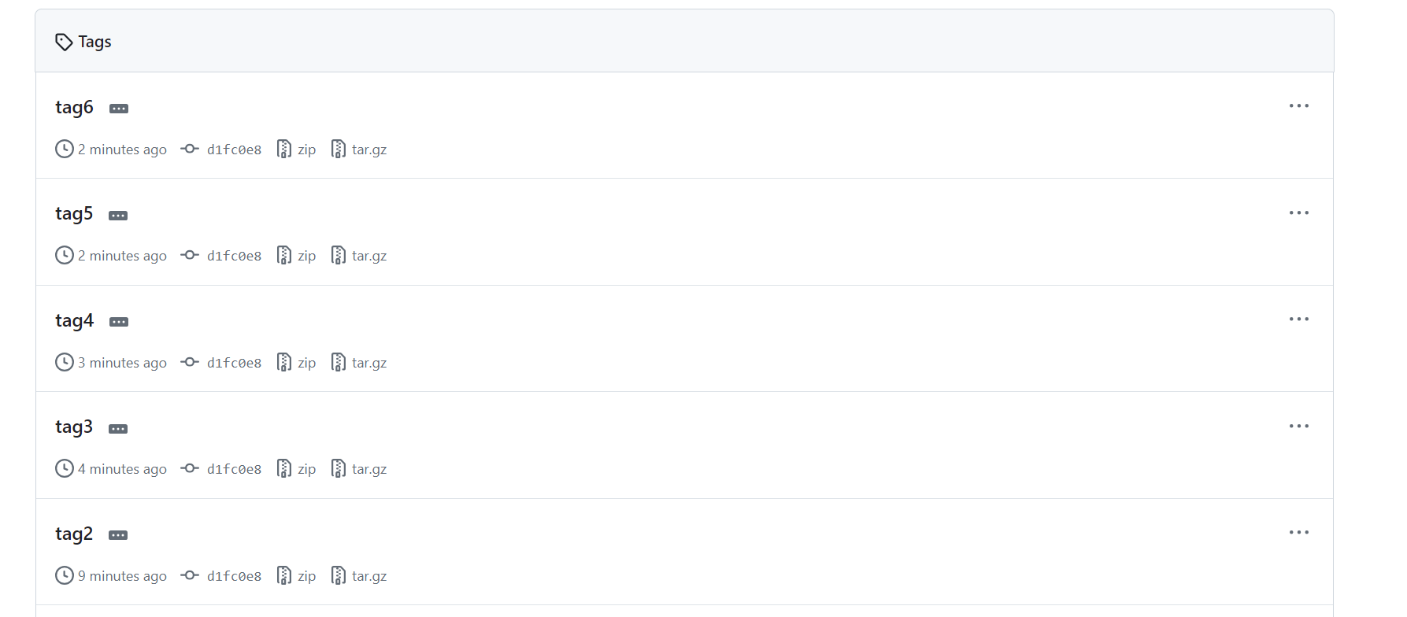

Create a Keygen and push using ssh

